# EXPERIMENT : 1 LED FLASHER

## DIAGRAM:-

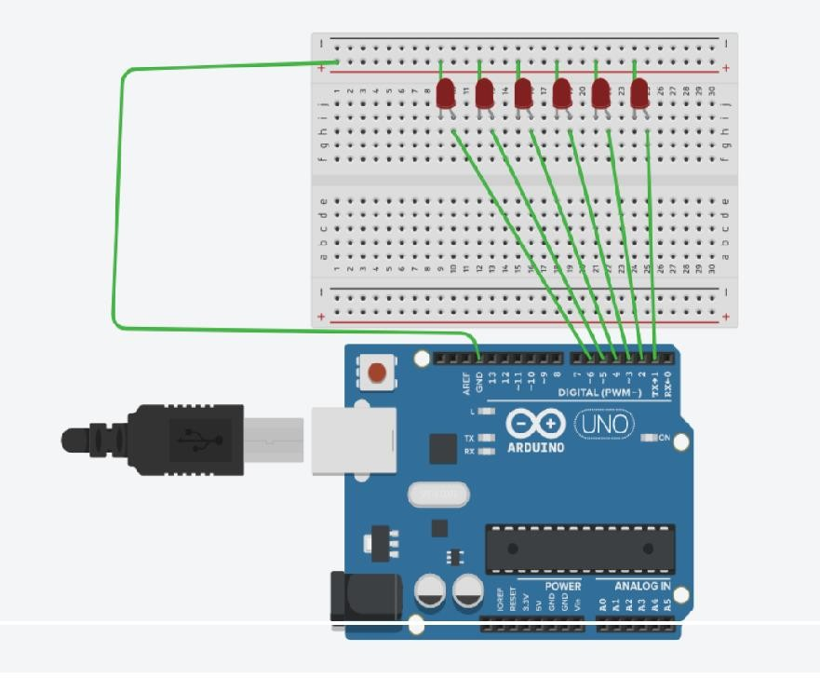

**THEORY:**

CONCEPT USED- The concept of the following experiment is state as,the six led’s will blink all together. Then they all delay for few time ,then again get off for a while.This thing will going continuously.

LEARNING AND OBSERVATIONS-

➔ There is no need of any resistor while working we led on ardiuno to reduce power supply.

➔ We learn how to code in ardiuno.

➔ We learn about the use of all basic functions and for loop.

## PROBLEMS AND TROUBLESHOOTING –

➔ At the coding process we have to precisely use the delay function.

➔ While during connections it is important to do all connection in a sequence manner otherwise for loop will not be used while during program.

# PRECAUTIONS -

➔ Wiring should be done properly,neatly.

➔ Do not use excess wires try to reduce number of wires used.

➔ Program should be written without giving delay between last led off and next led on.

# LEARNING OUTCOMES –

We learn to code and how to make circuit using ardiuno.